# A PROJECT SOFTWARE REQUIREMENTS SPECIFICATION

“Facial Expressions Detection System using AI Based Techniques”

**SUBMITTED TO SAVITRIBAI PHULE PUNE UNIVERSITY**

# UNDER THE GUIDANCE OF

**Prof. Kalyani Alishetty mam**

**SUBMITTED BY**

***ADITYA RAWAT AND***

***EDWIN AUCHITE***

**TABLE OF CONTENTS**

1. Abstract….......................................................................................................1

2. Introduction ....................................................................................................2

3. Related Work…...............................................................................................5

4. Objectives Of Project.......................................................................................6

5. Feasibility Study..............................................................................................7

6. Methodology....................................................................................................8

7. Plan Of Work...................................................................................................9

8. Facilities Required For Proposed Work...........................................................10

9. References........................................................................................................12

**ABSTRACT**

These Human facial expressions convey a lot of information visually rather than articulately. Facial expression recognition plays a crucial role in the area of human-machine interaction. Automatic facial expression recognition system has many applications including, but not limited to, human behavior understanding, detection of mental disorders, and synthetic human expressions. Recognition of facial expression by computer with high recognition rate is still a challenging task.

Two popular methods utilized mostly in the literature for the automatic FER systems are based on geometry and appearance. Facial Expression Recognition usually performed in four-stages consisting of pre-processing, face detection, feature extraction, and expression classification.

In this project we applied various deep learning methods (convolutional neural networks) to identify the key seven human emotions: anger, disgust, fear, happiness, sadness, surprise and neutrality.

**INTRODUCTION**

These Human facial expressions convey a lot of information visually rather than articulately. Facial expression recognition plays a crucial role in the area of human-machine interaction. Automatic facial expression recognition system has many applications including, but not limited to, human behaviour understanding, detection of mental disorders, and synthetic human expressions. Recognition of facial expression by computer with high recognition rate is still a challenging task.

Our emotion is revealed by the expressions in our face. Facial Expressions plays an important role in interpersonal communication. Facial expression is a nonverbal scientific gesture which gets expressed in our face as per our emotions.Facial expressions convey non-verbal cues, which play an important role in interpersonal relations**.** Facial expressions recognition technology helps in designing an intelligent human computer interface.

Automatic recognition of facial expression plays an important role in artificial intelligence and robotics and thus it is a need of the generation. Some application related to this include Personal identification and Access control, Videophone and Teleconferencing, Forensic application, Human-Computer Interaction, Automated Surveillance, Cosmetology and so on.

With the advent of modern technology our desires went high and it binds no bounds. In the present era a huge research work is going on in the field of digital image and image processing. The way of progression has been exponential and it is ever increasing.

In this project we applied various deep learning methods (convolutional neural networks) to identify the key seven human emotions:

* **Neutral**
* **Angry**
* **Disgust**
* **Fear**
* **Happy**
* **Sadness**
* **Surprise**

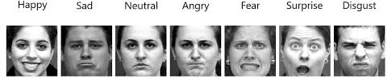

**FACIAL EXPRESSION DESCRIPTION OF SEVEN BASIC EMOTIONS:**

Facial muscles movements help in identifying human emotions. The facial features are the key parameters that can be considered for recognizing emotions. The facial parameters include eyebrow, mouth, nose, eyes and cheeks. Expressions of different or even the same people might vary for the same emotion, as emotions are hugely context dependent. While we can focus on only those areas of the face which display a maximum of emotions like around the mouth and eyes.

* **Happy**- The eyebrows are relaxed. The mouth is open and the mouth corners upturned.
* **Sad**- The inner eyebrows are bent upward. The eyes are slightly closed. The mouth is usually relaxed.
* **Fear**- The eyebrows are raised ad pulled together. The inner eyebrows are bent upward. The eyes are open and tense.
* **Anger**- The inner eyebrows are pulled downward and together. The eyes are wide open. The lips are tightly closed or opened to expose the teeth.
* **Surprise**- The eyebrows are raised. The upper eyelids and the eyes are wide open. The mouth is opened.
* **Disgust**- The eyebrows and eyelids are relaxed. The upper lip is raised and curled, often asymmetrically.
* **Neutral**- The eyebrows as well as the mouth are relaxed.

How we extract these gestures and categorize them is still an important question. Neural networks and machine learning have been used for these tasks and have obtained good results. Machine learning algorithms have proven to be very useful in pattern recognition and classification.

The human emotion dataset can be a very good example to study the robustness and nature of classification algorithms and how they perform for different types of dataset. Usually before extraction of features for emotion detection, face detection algorithms are applied on the image or the captured frame. We can generalize the emotion detection steps as follows:

* Dataset preprocessing
* Face detection
* Feature extraction
* Classification based on the features

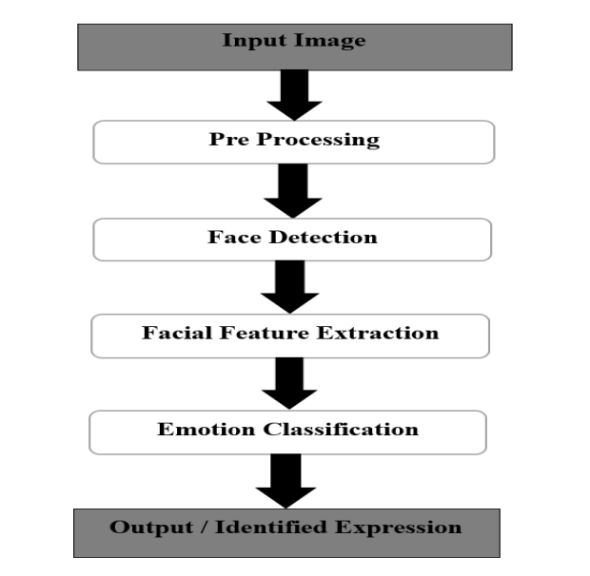

**Fig. Facial emotion recognition system flow**

**RELATED WORK**

For implementing this project four basic steps are required to be performed.

i. Preprocessing

ii. Face registration

iii. Facial feature extraction

iv. Emotion classification

Description about all these processes are given below:

* **Preprocessing** **:** Preprocessing is a common name for operations with images at the lowest level of abstraction both input and output are intensity images.
* **Face Registration :** Face Registration is a computer technology being used in a variety of applications that identifies human faces in digital images. In this face registration step, faces are first located in the image using some set of landmark points called “face localization” or “face detection”. These detected faces are then geometrically normalized to match some template image in a process called “face registration”.
* **Facial Feature Extraction :** Facial Features extraction is an important step in face recognition and is defined as the process of locating specific regions, points, landmarks, or curves/contours in a given 2-D image or a 3D range image. In this feature extraction step, a numerical feature vector is generated from the resulting registered image. Common features that can be extracted area. Lips b. Eyes c. Eyebrows d. Nose tip.
* **Emotion Classification :** In the third step, of classification, the algorithm attempts to classify the given faces portraying one of the seven basic emotions.

Approach which is followed for Facial Expression Recognition:

**Neural Network Approach :** The neural network contained a hidden layer with neurons. The approach is based on the assumption that a neutral face image corresponding to each image is available to the system. Each neural network is trained independently with the use of on-line back propagation.

**OBJECTIVE OF PROJECT**

The objective of Face Emotion Recognition (FER) is to identify the emotion of a human face. That is given a face of a human the system has to automatically identify the type of emotion of the face as happy, anger, disgust, fear, sadness, and surprise.

Several studies have been conducted in this area as there are large number of applications which directly or indirectly uses (FER).

The human brain recognizes emotions automatically, and software has now been developed that can recognize emotions as well. This technology is becoming more accurate all the time, and will eventually be able to read emotions as well as our brains do.

Facial Emotion Recognition(FER) is one of the useful tasks and important due to its use in real-time applications.

The recent advance in GPU has taken many applications like face recognition, hand written digit recognition and object recognition to the next level.

* The objective of face emotion recognition (FER) is identifying emotions of a human The emotion can be captured from face through camera.
* Psychological characteristics such as heartbeat and blood Pressure, speech,hand gestures, body movements, Facial expressions identify emotions of a person.
* It can be used as a part of many interesting and useful applications like Monitoring security, treating patients in medical field, marketing research, E-learning etc.
* The ability for a computer to recognize human emotion has many highly valuable real world applications. Consider the domain of therapy robots which are designed to provide care and comfort for infirm and disabled individuals.

***Hardware Interfaces :***

1. Processor: Intel CORE i5 processor with minimum 2.9 GHz speed.

2. RAM: Minimum 8 GB.

3. Hard Disk: Minimum 500 GB

4. Good GPU

***Software Interfaces :***

1.Microsoft Word 2011

2. Database Storage: Microsoft Excel

3. Operating System: Windows10

4. Jupiter notebook

5. Python

6. Anaconda

**FEASIBILITY STUDY**

It is important to note that there is no specific formula to build a neural network that would guarantee to work well. Different problems would require different network architecture and a lot of trail and errors to produce desirable validation accuracy. This is the reason why neural nets are often perceived as "black box algorithms".

For future work, a more robust face detection algorithm coupled with some good features can be researched to improve the results. We focused on only some distances and areas, there can be many more such interesting features on the face which can be statistically calculated and used for training the algorithm.

Not all the features help to improve the accuracy, some maybe not helpful with the other features. Feature selection and reduction technique can be implemented on the created feature to improve the accuracy of the dataset. We can experiment with facial action coding system or feature descriptors as features or a combination of both of them.

Also, we can experiment with different datasets amongst different races. This will give us an idea if the approach is similar for all kinds of faces or if some other features should be extracted to identify the emotion. Applications such as drowsiness detection amongst drivers can be developed using feature selection and cascading different algorithms together. Algorithms like logistic regression, linear discriminant analysis and random forest classifier can be fine-tuned to achieve good accuracy and results. Also, metrics such as cross validation score, recall and f1 score can be used to define the correctness of model and the model can be improved based on these metric results.

Further study can be laid down in the direction of allele of gene matching to the geometric factors of the facial expressions. The genetic property evolution framework for facial expressional system can be studied to suit the requirement of different security models such as criminal detection, governmental confidential security breaches etc.

**PLAN OF WORK**

The steps we followed while developing this project are:-

* Analysis of the problem statement.
* Gathering of the requirement specification
* Analyzation of the feasibility of the project.
* Development of a general layout.
* Choosing the method for developing the algorithm.
* Starting the development of the project.
* Developing an algorithm.
* Analyzation of algorithm by guide.
* Coding as per the developed algorithm in PYTHON.

We developed this project as per the iterative waterfall model:

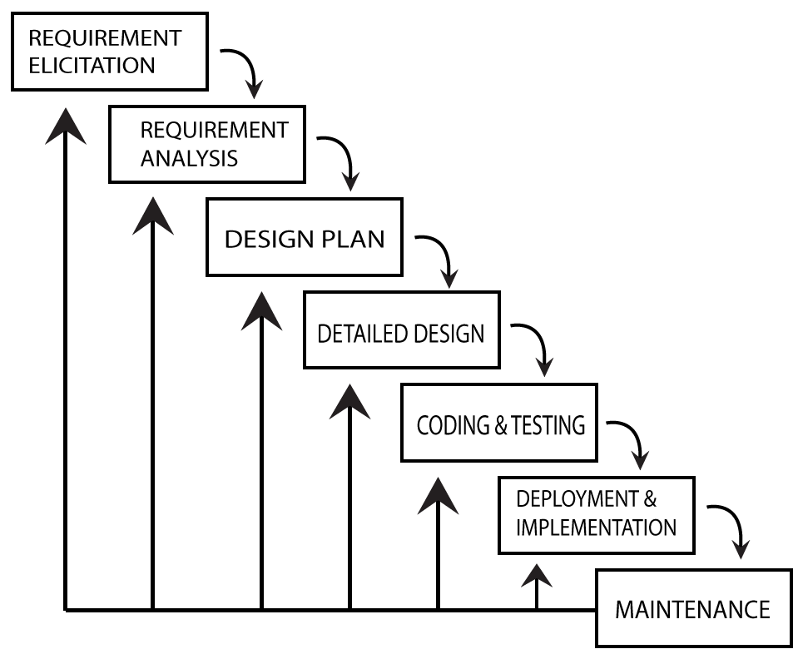

**METHODOLOGY**

**Step 1:** Collection of a data set of images.

(pre-cropped, 48-by-48-pixel grayscale images of faces each labeled with one of the 7 emotion classes):

anger, disgust, fear, happiness, sadness, surprise, and neutral.

**Step 2:** Pre-processing of images.

**Step 3:** Detection of a face from each image.

**Step 4:** The cropped face is converted into grayscale images.

**Step 5:** The pipeline ensures every image can be fed into the input layer as a (1, 48, 48) numpy array.

**Step 6:** The numpy array gets passed into the Convolution2D layer.

**Step 7:** Convolution generates feature maps.

**Step 8:** Pooling method called MaxPooling2D that uses (2, 2) windows across the feature map only keeping the maximum pixel value.

**Step 9:** During training, Neural network Forward propagation and backward propagation performed on the pixel values.

**Step 10:** The Softmax function presents itself as a probability for each emotion class.

The model is able to show the detail probability composition of the emotions in the face.

**Technologies Used**

* **Anaconda**

It is a free and open source distribution of the Python and R programming languages for data science and machine learning related applications, that aims to simplify package management and deployment.

* **Jupyter Notebook**

It is an open-source web application that allows you to create and share documents that contain live code, equations, visualizations and narrative text.

* **Google Colab**

It allows anybody to write and execute arbitrary python code through the browser, and is especially well suited to machine learning, data analysis and education.

* **Python**

Python is a powerful scripting language and is very useful for solving statistical problems involving machine learning algorithms. It has various utility functions which help in preprocessing. It provides the pandas and numpy framework which helps in manipulation of data as per our need.

**Libraries And Packages**

* **OpenCV**

OpenCV (Open Source Computer Vision Library) is an open source computer vision and machine learning software library. OpenCV was built to provide a common infrastructure for computer vision applications and to accelerate the use of machine perception in the commercial products.

* **Numpy**

NumPy is an acronym for "Numeric Python" or "Numerical Python". It is an open source extension module for Python, which provides fast precompiled functions for mathematical and numerical routines.

* **Haar Cascade Classifier in OpenCv**

It is a machine learning based approach where a cascade function is trained from a lot of positive and negative images. It is then used to detect objects in other images.Here we will work with face expression detection.

* **Keras**

Keras is a high-level neural networks API, written in Python and capable of running on top of TensorFlow, CNTK, or Theano. It was developed with a focus on enabling fast experimentation.

* **TensorFlow**

TensorFlow is a Python library for fast numerical computing created and released by Google. It is a foundation library that can be used to create Deep Learning models directly or by using wrapper libraries that simplify the process built on top of TensorFlow.

**REFERENCES**

1. A literature survey on Facial Expression Recognition using Global Features by Vaibhav kumar, J. Mistry and Mahesh M. Goyani, International Journal of Engineering and Advanced Technology (IJEAT),April,2013

[http://citeseerx.ist.psu.edu/viewdoc/download?doi=10.1.1.645.5162&rep=rep1&type=pdf]

2. Convolutional Neural Networks (CNN) With TensorFlow by Sourav from Edureka [https://www.youtube.com/watch?v=umGJ30-15_A]

3. Deep Learning Simplified by Sourav from Edureka [https://www.youtube.com/watch?v=dafuAz_CV7Q&list=PL9ooVrP1hQOEX8BKDplfG86ky8s7Oxbzg]

4. “Robust Real-Time Face Detection”, International Journal of Computer Vision 57(2), 137–154, 2004.

5. VIOLA JONES FACE DETECTION EXPLAINATION by Rahul Patil.

6.Project_Report_On_FACIAL_EXPRESSION_RECOGNITION_USING_IMAGE_PROCESSING

7. Facial Expression Detection Techniques: Based on Viola and Jones algorithm and Principal Component Analysis by Samiksha Agrawal and Pallavi Khatri, ITM University Gwalior(M.P.), India, 2014.

8. Online publication on Convolutional Neural Networks: An Intro Tutorial by Derrick Mwiti.

[https://heartbeat.fritz.ai/a-beginners-guide-to-convolutional-neural-networks-cnn-cf26c5ee17ed]